Nature of Science & Engineering: Conducting a Scientific Investigation Notes
September 22nd

The Scientific Method & Engineering Method
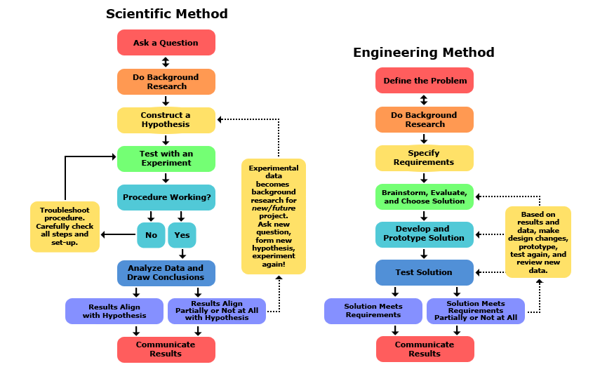
The Scientific Method
- Step 1
  - ___________________________________________
  - For example: “I wonder what type of bird seed I should put in my feeders.”
- Step 2
  - ___________________________________________
  - Head to the library for resources, do online research, ask someone at a retail store that sells bird seed
- Step 3
  - __________________________________________
  - An Observation is noting or detecting phenomenon through the senses.
  - Spend time watching birds in the wild or at other feeders.
- Step 4
  - Construct a ________________ based on an __________________.
  - A __________________ is a suggested explanation based on evidence that can be tested by observation or experimentation.
  - ___________________ statement
  - “If birds like a variety of seeds in the wild, then they prefer a mixed seed at the feeders.”
- Step 5
  - ________________________________
  - An __________________ is a special type of investigation that is performed under _______________________________ to test a hypothesis
- Step 5 (con’t)
  - Test Variables - ___________________________________________________________________________________________________________________________________________________________________________
  - Two types:
    - ___________________________________________________ – the variable in an experiment that is being measured.
    - ____________________________________________________ – the variable in an experiment that is being changed to observe the effect on the dependent variable.

- Step 5 (con’t)
  - Bird Seed Experiment:
    - Dependent Variable: ________________________________________________________________________________________________________
    - Independent Variable: ________________________________________________________________________________________________________
  - You will record the amount of bird seed consumed by the birds for each of the different types of seed.
  - You will offer at least two different types of seed for the birds.
    - Mixed seeds (going back to your hypothesis)
    - Another type of seed based on your background research and/or observations (maybe sunflower seeds)
- Step 6
  - __________________________
  - Have step by step detailed instructions on how to set up and run the experiment so that anyone can duplicate it
  - Step 1: Set out two identical bird feeders – one with 8 cups of mixed seed, one with 8 cups of sunflower seeds
- Step 7
  - __________________________ – is the procedure working?
  - If not, figure out __________________________________________ to better answer your question.
  - Are squirrels getting to the feeders and eating all the seeds? You may need to change the location of the feeders.
  - Note changes to the procedure.

- Step 8
  - __________________________________________
  - Be sure to collect enough data – make observations at least ____________________________
  - For example: set out, collect and weigh the remaining bird seed three times and calculate the average amount of seed left over
- Step 8 (con’t)
  - _________________________
  - Make charts, graphs, tables, etc. to show your data
  - Do not make tables and graphs that show the same thing!
  - For example:
    - Make a graph comparing the amount of seed left over from the three trials from each bird feeder
    - Make a table showing the average amount of seed left over
- Step 9
  - ________________________– the data you collected!
  - Show these using your graphs, charts, tables, etc. AND ________________________________ those tables and results.
- Step 10
  - _______________________ – What did you learn from your results?
  - Can you accept your _______________?
    - Do birds prefer mixed seeds at bird feeders based on your experiment?
  - You may have to _____________ your hypothesis. (And that’s okay!)
  - If you reject your hypothesis, how can you retest?
  - What changes would you make to your experimental method?

- Step 11
  - _______________________________________
  - Presentation! Report!
  - Compile all your hard work – question, research, hypothesis, materials, procedure, results, and conclusion – and present it to classmates, coworkers, etc. in the form of a research paper or presentation

