Wolsfeld Woods SNA Population Study
Trees of Wolsfeld Woods SNA
Sugar Maple Leaf 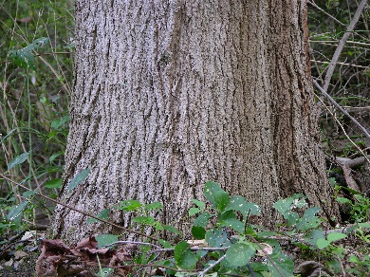 Sugar Maple Bark

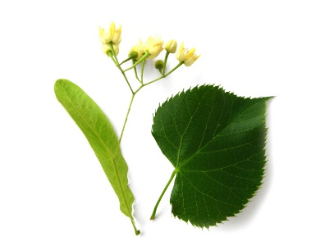Basswood Leaf 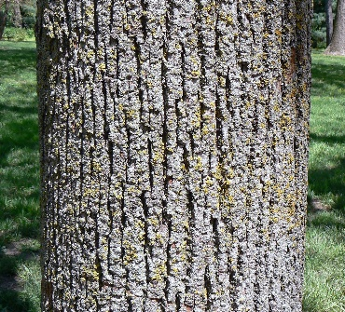 Basswood Bark

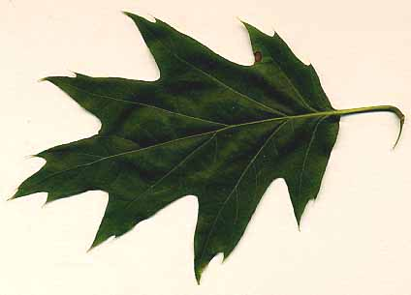Red Oak Leaf 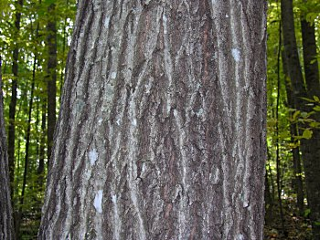 Red Oak Bark

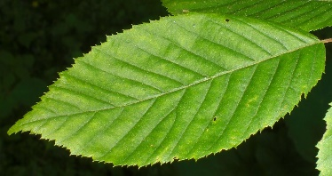Ironwood Leaf 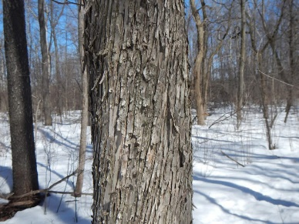 Ironwood Bark

Which tree species is the dominant tree species in Wolsfeld Woods Scientific and Natural Area?
Dominant Tree Species = most abundant and largest diameter

Transect 1 Description: _______________________________
Distance (ft) | Tree Species | Diameter (inches)
Transect 2 Description: _______________________________

Distance (ft) | Tree Species | Diameter (inches)

Transect 3 Description: _______________________________

Distance (ft) | Tree Species | Diameter (inches)

Transect 4 Description: _______________________________

Distance (ft) | Tree Species | Diameter (inches)

Transect 5 Description: _______________________________

Distance (ft) | Tree Species | Diameter (inches)

Fill in this table using the data from all 5 transects.

Tree Species | Number of Trees | Avg. Tree Diameter
Basswood
Ironwood
Red Oak
Sugar Maple

Which tree species do you think is the dominant trees species of Wolsfeld Woods SNA?
_____________________________________________________

Why? __________________________________________________________________________________________________________

